Image Enhancement techniques (Point processing)
Code:
import cv2
import numpy as np
image = cv2.imread('aslan.jpg')
if image is None:
print("Error: Image not found.")
exit()
gray_image = cv2.cvtColor(image, cv2.COLOR_BGR2GRAY)
equalized_image = cv2.equalizeHist(gray_image)
clahe = cv2.createCLAHE(clipLimit=2.0, tileGridSize=(4, 4))
clahe_image = clahe.apply(gray_image)
gamma = 1.5
gamma_corrected = np.array(255 * (image / 255) ** gamma, dtype='uint8')
kernel = np.array([[0, -1, 0],
[-1, 5, -1],
[0, -1, 0]])
sharpened_image = cv2.filter2D(image, -1, kernel)
gaussian_blur = cv2.GaussianBlur(image, (3, 3), 0)
cv2.imshow('Original Image', image)
cv2.imshow('Grayscale Image', gray_image)
cv2.imshow('Histogram Equalization', equalized_image)
cv2.imshow('CLAHE (Adaptive Histogram)', clahe_image)
cv2.imshow('Gamma Correction', gamma_corrected)
cv2.imshow('Sharpened Image', sharpened_image)
cv2.imshow('Gaussian Blur (Smoothing)', gaussian_blur)

cv2.waitKey(0)
cv2.destroyAllWindows()

Code Explanation:
- Image Loading:
  - The image aslan.jpg is loaded using cv2.imread.
  - If the image is not found, the script exits with an error message.
- Grayscale Conversion:
  - The color image is converted to grayscale using cv2.cvtColor.
  - Grayscale simplifies image processing by reducing the data to a single intensity channel.
- Histogram Equalization:
  - Improves contrast by redistributing pixel intensity values in the grayscale image.
  - It spreads out the most frequent intensity values for better visibility.
- CLAHE (Contrast Limited Adaptive Histogram Equalization):
  - A localized version of histogram equalization that adjusts contrast in small regions of the image.
  - The clipLimit prevents over-amplification of noise.
- Gamma Correction:
  - Applies nonlinear transformation to adjust the brightness of the image.
    - A gamma value > 1 brightens the image.
    - A gamma value < 1 darkens the image.
  - This is calculated as output = input^(gamma).
- Sharpening:
  - Enhances edges and fine details using a sharpening kernel.
  - The convolutional kernel applied with cv2.filter2D emphasizes high-frequency details.
- Gaussian Blur:
  - Reduces noise and smooths the image using a Gaussian filter with a kernel size of (7, 7).
  - This is useful for preprocessing or aesthetic smoothing.
- Display Results:
  - Each processed image is displayed in a separate window using cv2.imshow.
  - The program waits for a key press before closing all windows with cv2.destroyAllWindows.

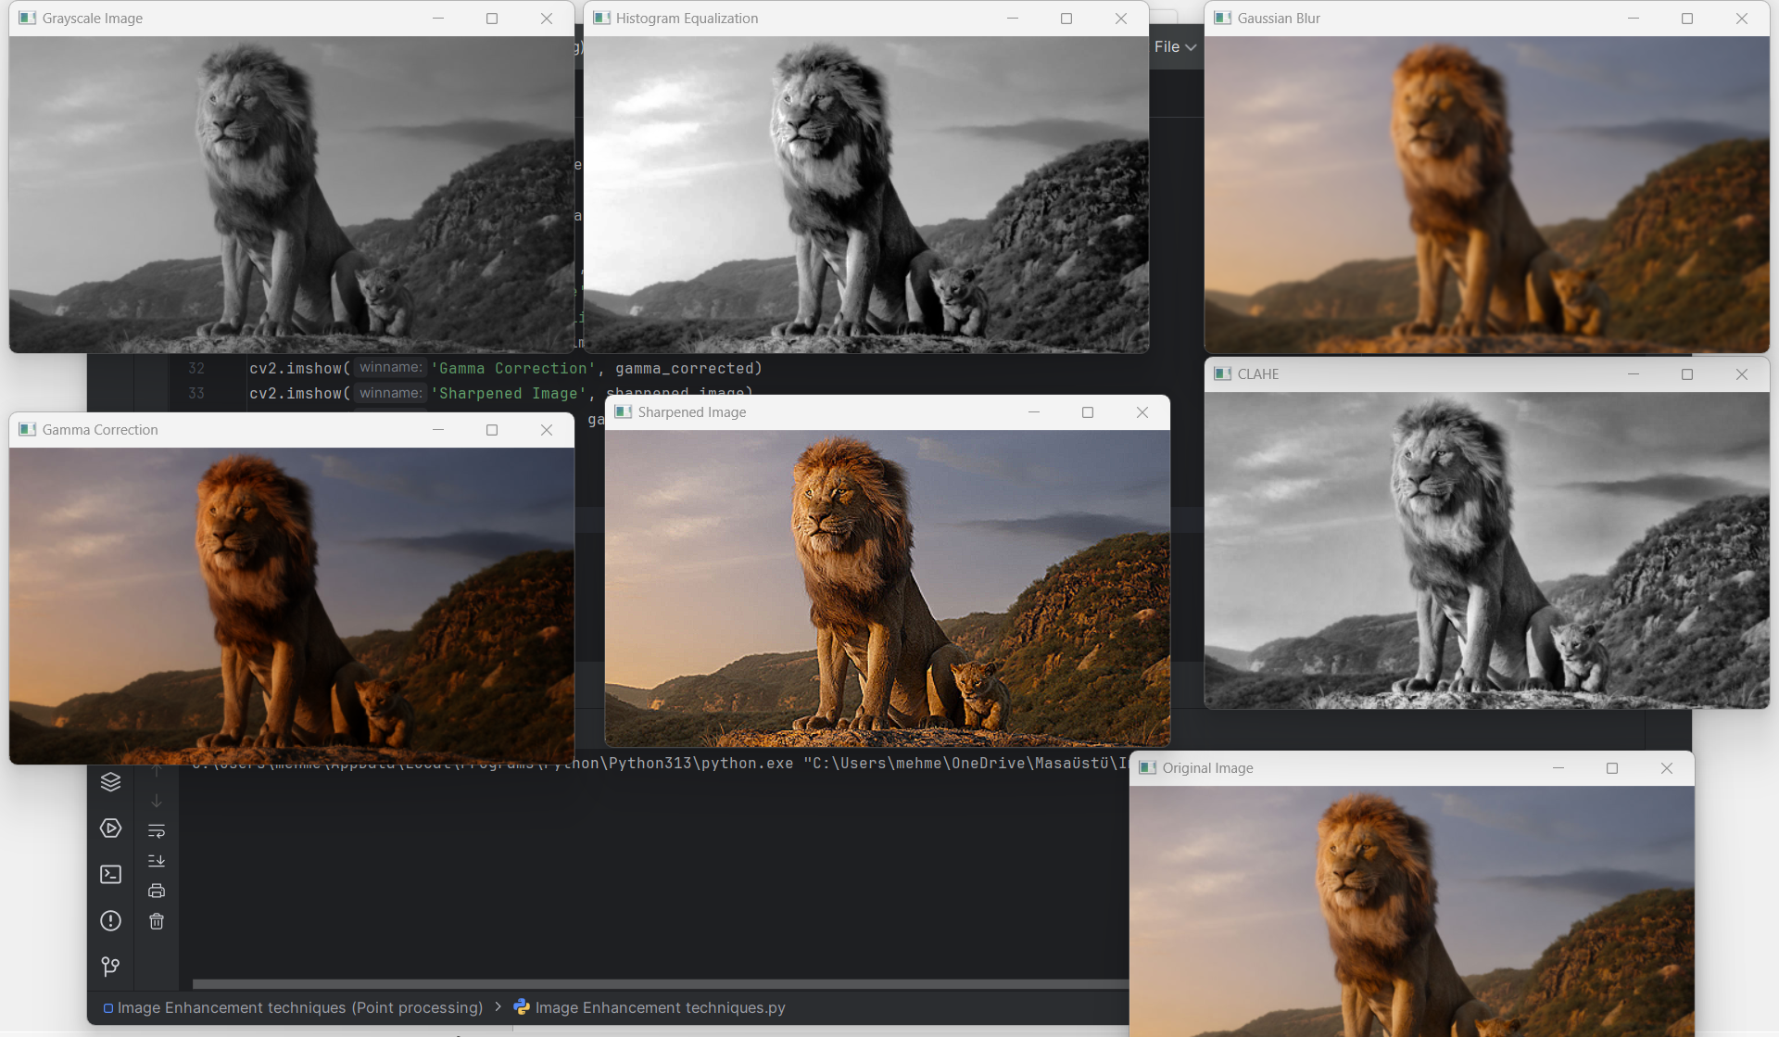
Output:

Report
Objective:
The code demonstrates various techniques to enhance image quality, focusing on contrast, brightness, detail sharpness, and noise reduction.
Techniques Used:
- Histogram Equalization:
  - Enhances global contrast, ideal for grayscale images.
- CLAHE:
  - Adjusts contrast adaptively, preserving details in localized areas.
- Gamma Correction:
  - Brightens or darkens the image based on the gamma value.
- Sharpening:
  - Highlights edges, improving the perceived clarity of details.
- Gaussian Blur:
  - Reduces noise and smooths the image for a cleaner appearance.
Results:
- Histogram Equalization and CLAHE improve contrast effectively, with CLAHE better preserving localized details.
- Gamma Correction adjusts brightness dynamically, useful for enhancing dark or overly bright images.
- Sharpening brings out edges but may amplify noise.
- Gaussian Blur smooths the image, useful for reducing noise but at the cost of slight detail loss.
Conclusion:
These techniques demonstrate the versatility of OpenCV in image enhancement. Depending on the use case, specific methods or combinations can be applied to improve image quality for visualization or further processing.

